Child Theme Development

07 Child Theme dev

Place holder Screenshot

Tony Evans

See next page for screenshots of what your page should look like

# Widgets

In this session create a custom widget area on a page.

To do this, open the functions.php file. Scroll down till you see the included code in the file.

//*********Building a widget called mychildtheme widget**********

function mychildtheme_widget_init() {

register_sidebar( array(

'name'=> 'My new Widget Area',

'id' => 'my_new_widget_area',

'before_widget' => '<aside>',

'after_widget' => '</aside>',

'before_title' => '<h3 class="widget-title">',

'after_title' => '</h3>',

));

}

add_action( 'widgets_init','mychildtheme_widget_init');

The above code starts the widget creation.

The **next step** is to place the widget where you want on the page. In this case a file called “index-with-widget-area.php” already includes a code snippet towards the bottom of the page.

<h1>TEST</h1>

<?php if( dynamic_sidebar('my_new_widget_area')) : else : endif; ?>

So far when you look at the page in the activated child theme, there is no widget appearing. To make it appear, go to the admin panel and under Appearance click widgets. In this area you should see a section named “My new widget area” same as the name in the above code.

You can drag a widget into the new area to see what it does. Try dragging a calendar onto this area and give it a name.

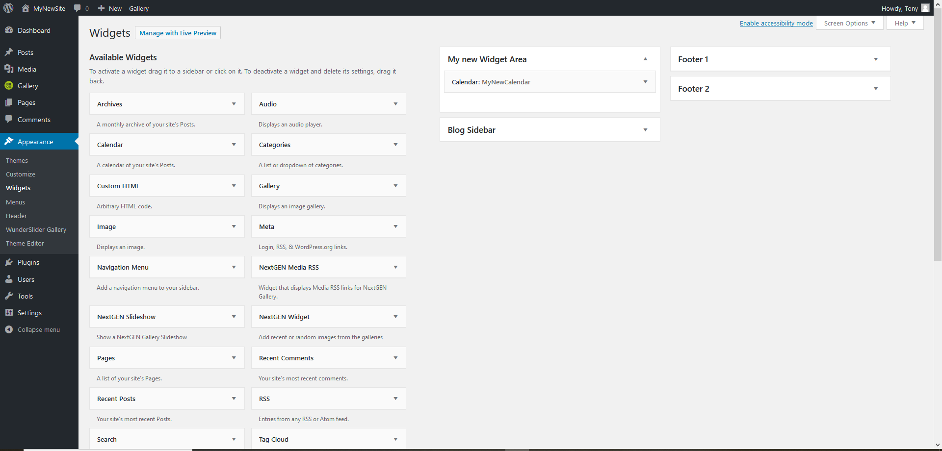

To get the page to look like the following screen shot, rename the file “index-with-widget-area.php” to “index.php”.

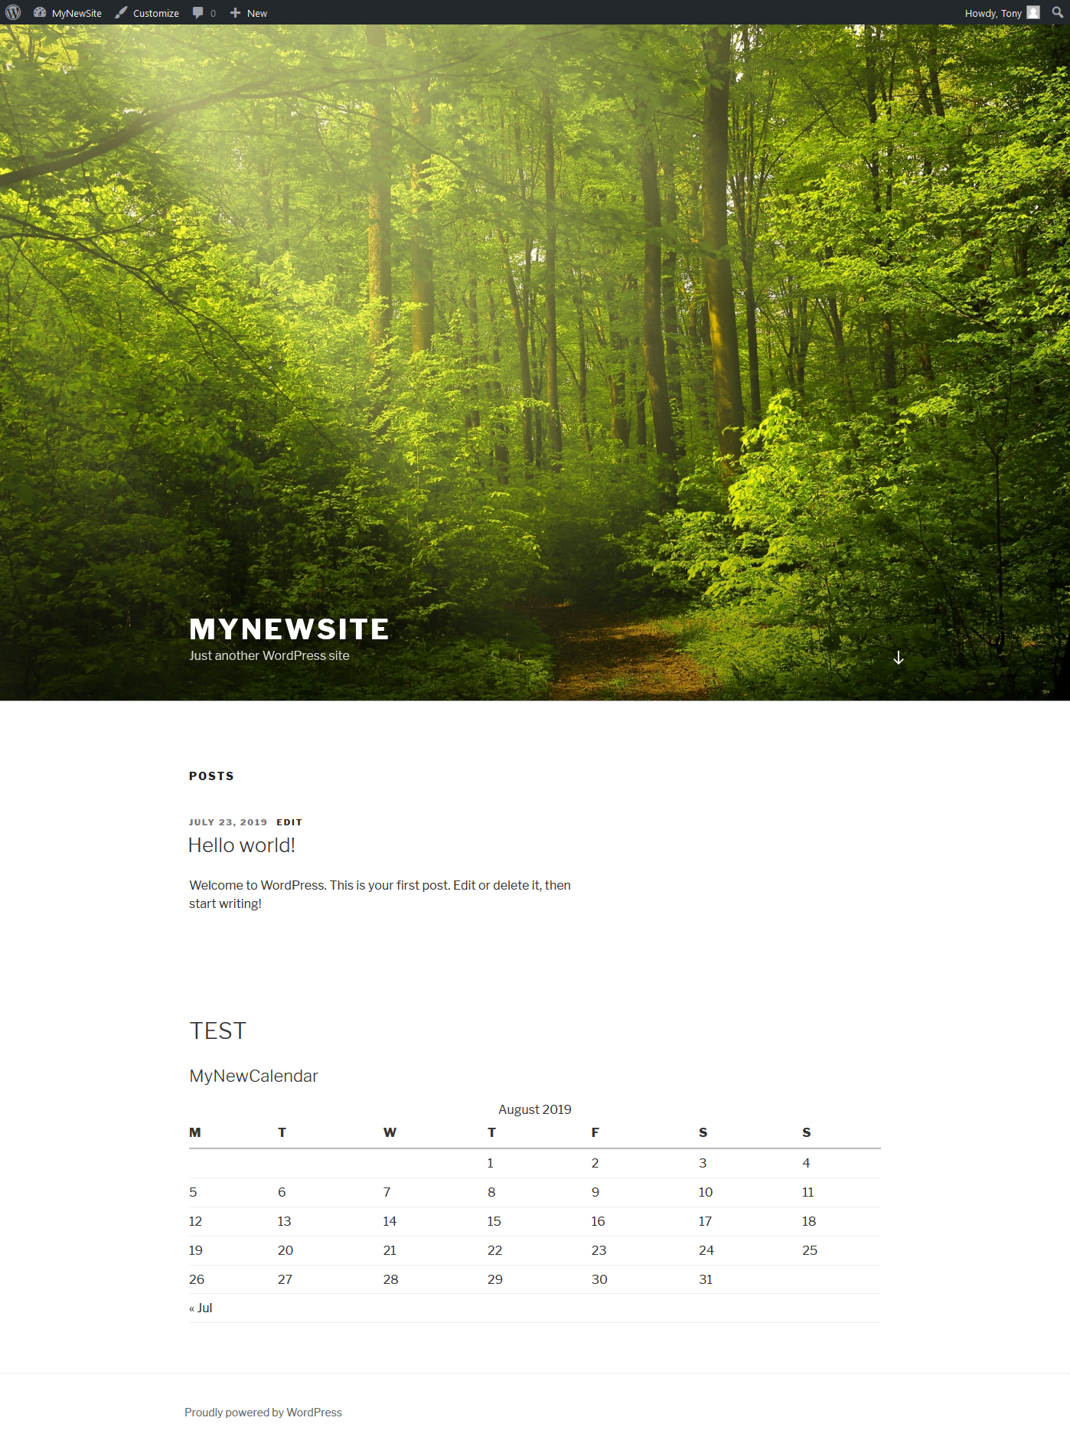

If you look at the code that has been added into the page using developer tools you can see the code added from the functions file. Look at the “before widget => ‘<aside>’,”

'before_widget' => '<aside>',

'after_widget' => '</aside>',

'before_title' => '<h3 class="widget-title">',

'after_title' => '</h3>',

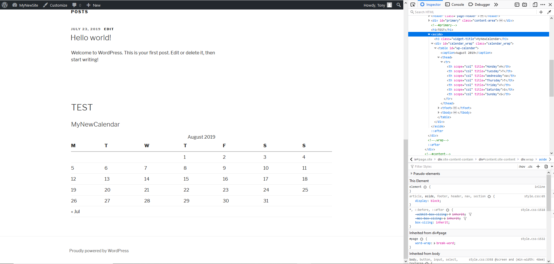

**This session has included the folders and file with modifications.**

**You only need to add the widget to the widget area in the admin panel.**